Organization Work Environment

Revision History

Version Number | Creation/  Revision Date | Prepared /Updated By | Reviewed By | Approved By | Change Description

- Available Environment Details
- All the meeting rooms are provided with Chairs and adequate white board facility.
- Seating workspace includes chairs, desks, UPS and Direct power sockets and cup boards.
- Centralized Air conditioner with Min 22.5 C and with Max 23.5 C maintained in working condition.
- All the workspaces are provided with adequate illumination of white light.
- Fire extinguishers are stored at all the entrances and in important places of the work environment
- Floor diagram is available in all the places to help emergency exits.
- The buildings are provided with clean sanitary faculties and maintained at every hour.

- Server Inventory

The entire Software Inventory list is maintained in the software inventory list

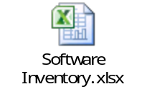

- Hardware & Network Inventory

The entire Hardware & Network Inventory list is maintained in the following document

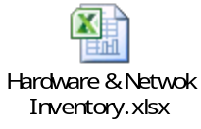

- Server List

The entire Servers list is maintained in the following document

